Shipley Do-Nuts
Standard Operating Procedure (SOP)
Sticky Printer Configuration
Version 1.0

Purpose
This SOP describes the complete process for configuring a Beverage Sticky Printer for Shipley Do-Nuts locations, including Scale (Acumera) whitelisting, NCR Kitchen Routing configuration, routing validation, and POS configuration.

Step 1 – Whitelist the Sticky Printer in Scale
Connect the Sticky Printer to the store switch using the NCRS network segment.
Locate the device in Scale (Unregistered Devices). (vendor Bixolon Co)
Register the device with the name 'Sticky Printer'.
Assign the Internet/Access policy to the device.
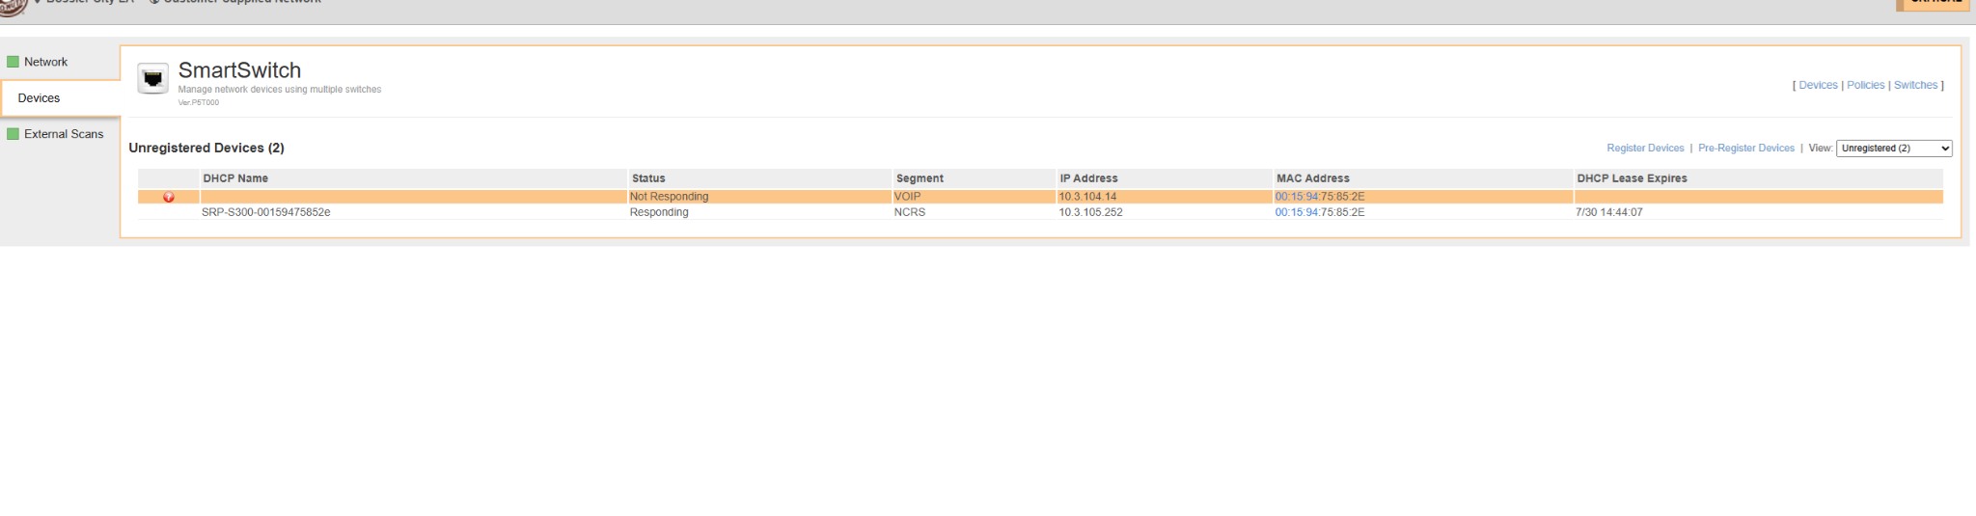
Verify the device is registered and online.
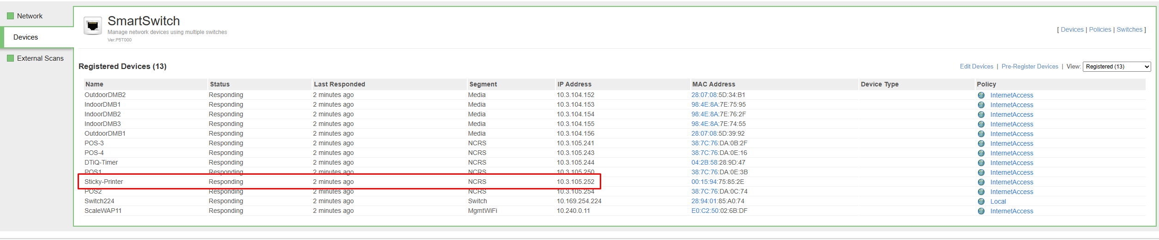

Step 2 – Configure Kitchen Routing in NCR
Navigate to Settings & Privacy > Kitchen Routing Setup.
Select Add Kitchen Device.
Create a new printer named 'Beverage Sticky Printer'.
Enable the option 'One Item Per Chit'.
Save the configuration.
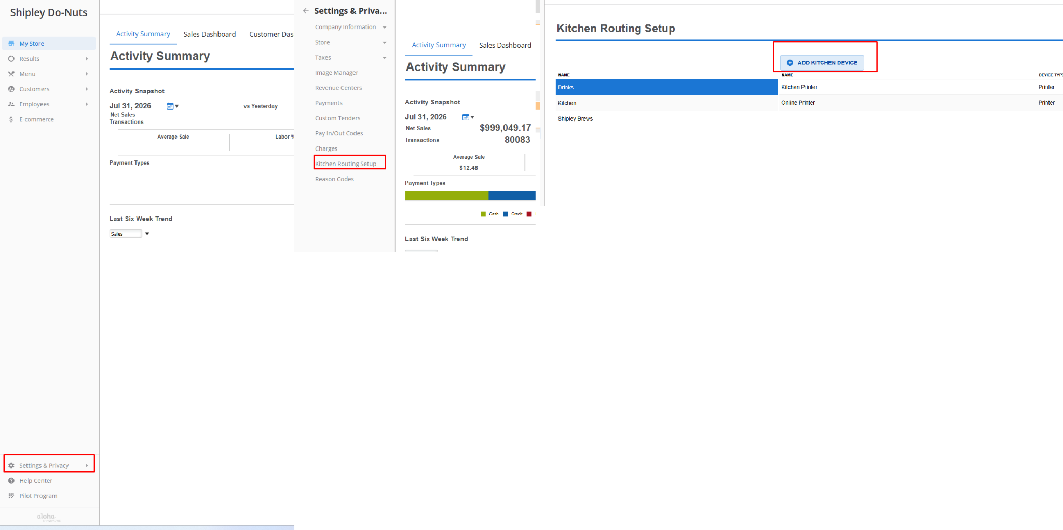
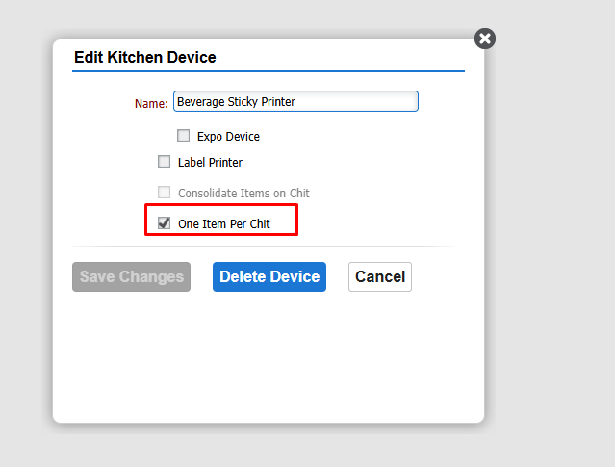

Step 3 – Verify Kitchen and Drinks Routing
Select the Drinks category and verify that NO checkboxes are enabled for Dine In, Takeout, Delivery, or Drive Thru on Beverage Sticky Printer row.
Repeat the same verification for the Kitchen category.
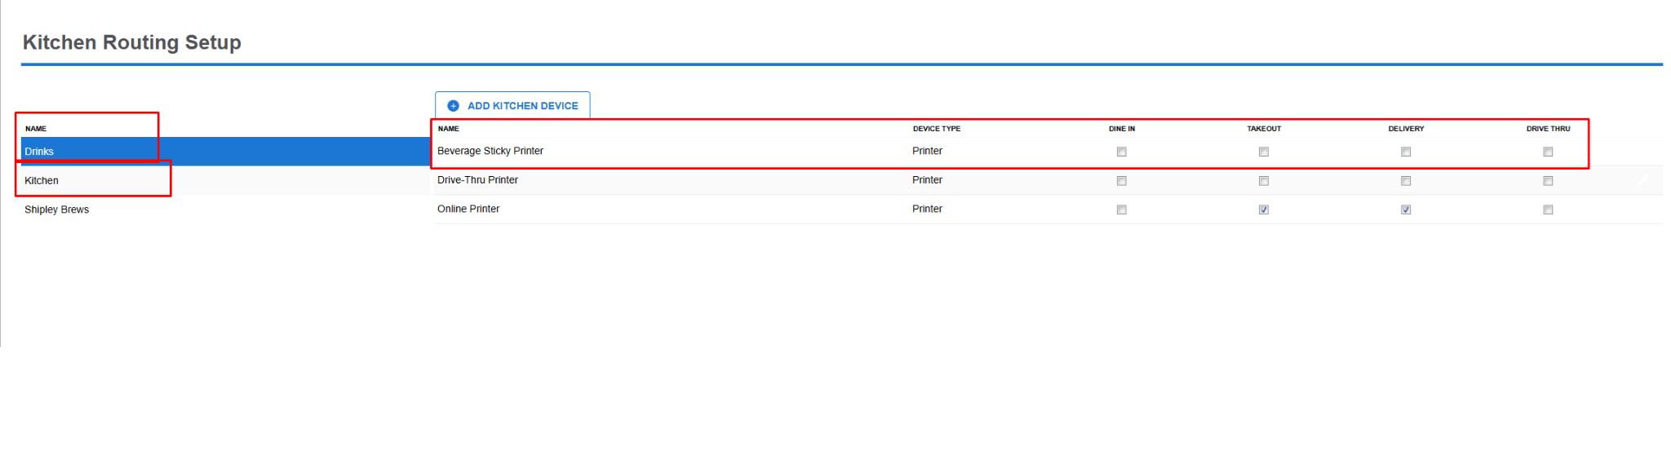

Step 4 – Configure Shipley Brews
Select the Shipley Brews category.
Assign all routing options (Dine In, Takeout, Delivery, and Drive Thru) to the Beverage Sticky Printer.
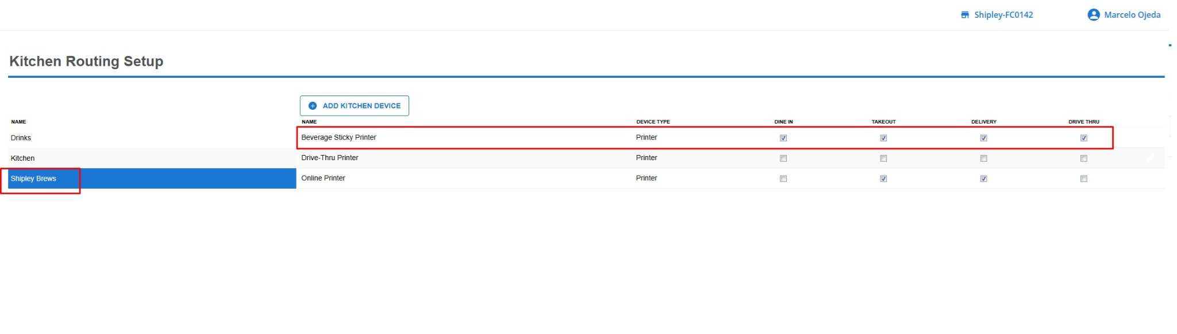

Step 5 – Configure the Sticky Printer on Every POS
While on a call with the customer, configure the Sticky Printer on EVERY POS terminal.
On each POS go 3 horizontal lines:
1. Open Settings.
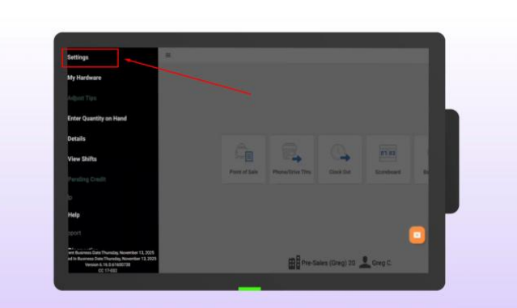
2. Select Kitchen Printers.
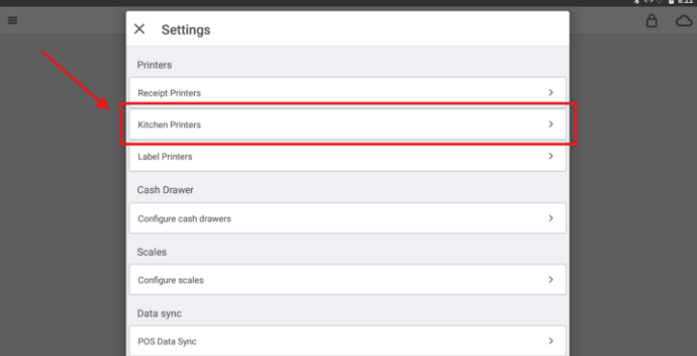
3. Tap Add Local Printer.
4. Select Network Printer. And DONT CLICK ON IDENTIFY.
5. Select the Sticky Printer.
6. Confirm the printer (green check) and then Tap the check mark to save.
7. And should be showing like this:
Repeat this process on every POS in the store.

